

**Attendance Policy**

|  |  |
| --- | --- |
| **Policy Owner** | Interim Director of Performance / Trust Attendance Lead |
| **Approved by** | * CEO * Education Standards Committee |
| **Last reviewed on** | September 2024 |
| **Next review date** | September 2025 |

Contents

1. Aims: 4

1. Legislation: 6

2. Roles and responsibilities: 7

Key Contacts 7

**1. School Principal/Headteacher/Senior attendance champion** 8

**2. Attendance Officer/Attendance Coordinator** 8

**3. Classroom Teachers** 8

**4. Head of Year/Year Group Leader** 9

**5. Child Support Services; including safeguarding teams** 9

**6. School Secretary/Admin Staff** 9

**7. Special Educational Needs Coordinator (SENCO)** 9

**8. Families** 9

**9. Governing Body/School Board** 10

**10. External Partners and Community Agencies** 10

3. Support and Interventions: 11

**Tier 1: Universal Interventions** 11

**Tier 2: Targeted Interventions** 12

**Tier 3: Intensive Interventions** 13

4. Recording attendance: 14

**Attendance Register** 14

**Formal Attendance Recording** 14

**Recording Absences** 15

**Lateness and Early Departures** 15

**Communication with Families** 15

**Attendance Reports** 15

**Confidentiality and Data Security** 15

5. Training and Support 16

6. Procedures for Recording Attendance 16

7. Unplanned absence 17

8. Planned absence 17

9. Lateness and punctuality 18

10. Approval for term-time absence 19

11. Legal sanctions 20

12. Penalty notices 20

13. Notices to improve 21

14. Reducing persistent and severe absence 23

15. Alternative Provision 24

Appendix 1: DFE attendance codes 26

Appendix 2 - A Multi-Tiered System of Support 29

Appendix 3- Strategies for Promoting attendance: 32

1. Create a Positive School Climate 32

2. Clear Communication of Expectations 32

3. Recognition and Incentives 32

4. Parent and Community Engagement 32

5. Early Identification and Intervention 32

6. Child Support Services 32

7. Engaging Curriculum and Instruction 33

8. Addressing Barriers to Attendance 33

9. Professional Development for Staff 33

10. Use of Technology 33

11. Celebrating Attendance Milestones 33

12. Support for Special Populations 33

Example of a Comprehensive Attendance Improvement Program: 33

# Aims:

This policy demonstrates how we meet our obligations with regards to school attendance, including those laid out in the Department for Education’s (DfE’s) statutory guidance on [working together to improve school attendance (applies from 19 August 2024)](https://www.gov.uk/government/publications/working-together-to-improve-school-attendance), through our whole-school culture and ethos that values good attendance we aim to;

1. Promote Regular Attendance

Encourage a culture where regular attendance is valued and seen as crucial for academic success and personal development.

Ensure that children and their families understand the importance of consistent attendance and its impact on learning outcomes.

1. Reduce Absenteeism

Identify and address the root causes of absenteeism, including health issues, family problems, and social or academic difficulties.

Implement interventions and support systems to assist children who are frequently absent or at risk of chronic absenteeism.

1. Early Intervention

Monitor attendance patterns closely to identify early signs of attendance issues.

Take proactive steps to intervene early, providing support and resources to children and families before attendance issues become chronic.

1. Improve Communication

Foster open and effective communication between the school, families, and children regarding attendance expectations and issues.

Use various channels (e.g., meetings, newsletters, digital platforms) to keep families informed about their child's attendance and any concerns.

1. Support Child Well-being

Ensure that the school environment is welcoming, inclusive, and supportive, addressing any barriers to attendance related to child well-being.

Provide access to counselling, health services, and other support mechanisms to help children attend school regularly.

1. Set Clear Expectations and Consequences

Clearly outline attendance requirements, procedures for reporting absences, and the consequences of unexcused absences.

Ensure that all stakeholders (children, families, staff) are aware of these expectations and the importance of adhering to them.

1. Involve the Community

Engage with community resources and organisations to support attendance initiatives and address external factors affecting attendance.

Collaborate with local agencies, health providers, and social services to create a network of support for children and families.

1. Use Data Effectively

Utilise data to monitor attendance trends, identify at-risk children, and measure the effectiveness of attendance initiatives.

Regularly review and analyse attendance data to inform policy decisions and improve strategies.

1. Celebrate and Reward Good Attendance

Recognise and reward children who achieve good attendance records through certificates, awards, or other incentives.

Highlight the achievements of children with improved attendance to encourage a positive attitude towards school attendance.

1. Ensure Compliance with Legal Requirements

Adhere to national and local attendance regulations and guidelines.

Ensure that the policy complies with any changes in legislation or educational standards.

Implementing these aims in the school attendance policy for 2024/25 can help foster a positive and supportive school environment that prioritises regular attendance and addresses absenteeism effectively.

# Legislation:

This policy is based on the Department for Education’s (DfE’s) statutory guidance on [working together to improve school attendance (applies from 19 August 2024)](https://www.gov.uk/government/publications/working-together-to-improve-school-attendance) and [school attendance parental responsibility measures](https://www.gov.uk/government/publications/parental-responsibility-measures-for-behaviour-and-attendance).

This attendance policy also operates within the framework of statutory attendance regulations outlined in the Education (Child Registration) (England) Regulations 2006 and subsequent amendments.

The policy gives due regard to departmental guidance, and the relevant signposted legislation contained therein.

# Roles and responsibilities:

# Key Contacts

Contact Details of School Staff at Woodlands Primary Academy.

|  |  |  |
| --- | --- | --- |
| **Name of Staff Member** | **Roles and Responsibilities** | **Contact Details** |
| Ben Driver | Director of Performance | ben.driver@creativeeducationtrust.org.uk |
| Jo Chambers | Trust Attendance Lead | jo.chambers@ creativeeducationtrust.org.uk |
| Ed Pearson-Shaul | Principal/Headteacher | ed.pearsonshaul@woodlandsprimaryacademy.org.uk |
| Ed Pearson-Shaul | Senior Leader Attendance Champion | ed.pearsonshaul@woodlandsprimaryacademy.org.uk |
| Becky Aldred | Attendance Admin | becky.aldred@woodlandsprimaryacademy.org.uk |
| Laura Brett | Safeguarding Leader (DSL) | laura.brett@woodlandsprimaryacademy.org.uk |
| Pam Ellis | Pastoral Support Officer | pam.ellis@woodlandsprimaryacademy.org.uk |
| Jennie Evans | SENDCo | Jennie.evans@woodlandsprimaryacademy.org.uk |

To ensure school attendance is everybody’s responsibility the below outlines key roles for all stakeholders.

1. **School Principal**

Policy Review and Development: Review and update the attendance policy as needed, in consultation with staff, parents, and children.

* Resource Allocation: Allocate necessary resources and support to facilitate attendance initiatives and interventions.

1. **Senior Leader Attendance Champion**

* Leadership and Oversight: Provide overall leadership and oversight of the attendance policy, ensuring it is effectively implemented across the school.
* Monitoring and Reporting: Monitor attendance data and progress, and report to the school governing body, Creative Education Board and relevant stakeholders.

**3. Attendance Improvement colleagues**

* Data Management: Maintain accurate attendance records and databases, ensuring all attendance data is up-to-date and securely stored.
* Monitoring and Analysis: Analyse attendance data to identify trends, patterns, and children at risk of absenteeism.
* Intervention Implementation: Develop and implement intervention strategies for children with poor attendance, coordinating with relevant staff and external agencies.
* Communication: Liaise with families, guardians, and external agencies to address attendance issues and support attendance improvement plans.
* Attendance contracts: Implement attendance contracts with children and their families, identifying support and interventions to remove barriers to attendance.

**4. Classroom Teachers**

* Attendance Monitoring: Take daily attendance and report any unexplained absences to the attendance officer or designated staff member.
* Early Identification: Identify and report any signs of absenteeism or disengagement, providing early warnings to the attendance officer.
* Engagement Strategies: Use strategies to engage children in learning and make the classroom environment welcoming and supportive.
* Ensure all children have access to the full curriculum: Identify any gaps in child learning and implement support to ensure children who are returning from absence have these gaps addressed.

**5. Head of Year**

* Support and Guidance: Provide support and guidance to children and staff within their year group regarding attendance policies and practices.
* Monitoring Children: Track the attendance of children within their year group, identifying those at risk of poor attendance and implementing targeted interventions.
* Parental Communication: Communicate with families regarding attendance issues, organising meetings and discussions as necessary.
* Attendance contracts: Implement attendance contracts with children and their families, identifying support and interventions to remove barriers to attendance.

**6. Child Support Services; including safeguarding teams**

* Counselling and Support: Provide counselling and support services for children facing personal, social, or academic challenges affecting their attendance.
* Referral to External Agencies: Refer children and families to external support services, such as social services, health services, or community organizations, when needed.
* Development of Support Plans: Develop and implement individualised support plans for children with persistent attendance issues.

**7. School Admin Staff**

* Attendance Records Management: Assist in maintaining attendance records and managing attendance-related administrative tasks.
* Communication: Send out attendance-related communications to parents, such as absence notifications, reminders, and attendance reports.
* Support for Reporting: Support the attendance officer and other staff in generating attendance reports and data analysis.

**8. Special Educational Needs Coordinator (SENCO)**

* Support for SEN Children: Ensure that attendance strategies are inclusive and tailored to meet the needs of children with special educational needs.
* Collaboration: Work with teachers, the attendance team and support staff to implement personalised attendance plans for SEN children.
* Reviews: To make attendance a focus in EHC and SEN review meetings and include attendance in targets and actions.
* Data: Analyse attendance data of SEND children to track and monitor when intervention is needed.
* Section 19: To work with local authorities and SEND teams to action SEND children who are eligible for section 19 intervention.

**9. Families**

* Daily attendance: To ensure children attend school daily and on time.
* Support and Engagement: Support their child’s education by promoting good attendance and working with the school to resolve any issues affecting attendance.
* Communication: Engage in regular communication with the school, responding promptly to attendance concerns and attending meetings when requested.

**10. School Board**

* Policy Oversight: Oversee the implementation of the attendance policy, ensuring it aligns with school goals and legal requirements.
* Review and Feedback: Review attendance data and policy effectiveness, providing feedback and recommendations for improvements.
* Support: To ensure there is a designated trust lead for attendance.

**11. External Partners and Community Agencies**

* Collaboration: Work collaboratively with the school to support attendance initiatives, providing resources, expertise, and services to address attendance barriers.
* Support Services: Offer additional support services, such as counselling, health care, or social services, to children and families as needed.

# Support and Interventions:

A Multi-Tiered System of Support (MTSS) for school attendance is an evidence-based framework that integrates various levels of interventions to improve child attendance. This approach ensures that all children receive the support they need to attend school regularly. The MTSS framework typically consists of three tiers: (See appendix 2 for the CET MTSS)

**Tier 1: Universal Interventions**

**Objective:** Promote good attendance for all children through school-wide initiatives and preventive measures.

**Strategies:**

1. **Clear Attendance Policies:** Establish and communicate clear attendance expectations and policies to children, parents, and staff.
2. **School Climate:** Foster a positive and inclusive school environment where children feel safe, valued, and engaged.
3. **Family Engagement:** Regularly communicate with families about the importance of attendance, using newsletters, meetings, and digital platforms.
4. **Recognition Programs:** Implement recognition and reward programs for children with excellent or improved attendance, such as certificates, awards, or special privileges.
5. **Curriculum and Instruction:** Ensure that the curriculum is engaging and relevant to encourage children to attend regularly. Ensure gaps in learning are addressed.
6. **Professional Development:** Train staff on the importance of attendance and effective strategies for promoting it.

**Tier 2: Targeted Interventions**

**Objective:** Provide additional support to children who are at risk of chronic absenteeism or have moderate attendance issues.

**Strategies:**

1. **Early Identification:** Use attendance data to identify stud
2. ents who have missed between 5-10% of school days and may be at risk of chronic absenteeism.
3. **Mentoring Programs:** Assign mentors or attendance buddies to at-risk children to provide guidance, support, and encouragement.
4. **Attendance Plans:** Develop personalised attendance improvement plans that address specific barriers to attendance, such as transportation issues or health problems.
5. **Family Meetings:** Hold meetings with families of at-risk children to discuss attendance concerns and collaboratively develop strategies to improve attendance.
6. **Check-In/Check-Out:** Implement a system where at-risk children check in with a designated staff member at the beginning and end of each school day to discuss attendance and any challenges they may be facing.
7. **Flexible alternatives:** Offer flexible alternatives or alternative educational programs for children who may struggle with the traditional school timetable. Where a child has an education health and care (EHC) plan and their attendance falls. Or the school becomes aware of barriers to attendance that relate to the child’s needs the school will inform the local authority.

**Tier 3: Intensive Interventions**

**Objective:** Provide intensive, individualised support for children with chronic absenteeism or severe attendance issues.

**Strategies:**

1. **Case Management:** Assign a case manager to work closely with chronically absent children and their families to address complex barriers to attendance.
2. **Wraparound Services:** Coordinate with community agencies to provide comprehensive support services, such as counselling, mental health services, healthcare, and social services.
3. **Home Visits:** Conduct home visits to understand the root causes of absenteeism and build stronger connections with families.
4. **Behavioural Interventions:** Implement intensive behavioural interventions and support plans for children with underlying behavioural issues contributing to absenteeism.
5. **Alternative Education Programs:** Provide access to alternative education programs or settings that may better meet the needs of children struggling in a traditional school environment.
6. **Legal Interventions:** As a last resort, collaborate with local authorities to enforce attendance laws and consider legal action when necessary to ensure compliance.

By implementing a Multi-Tiered System of Support for school attendance our school/ academy can create a structured and proactive approach to improving attendance, addressing barriers, and ensuring that all children have the opportunity to succeed academically.

See appendix 3 for our academy specific interventions.

# Recording attendance:

Recording school attendance accurately is essential for monitoring child engagement, identifying attendance issues, and complying with legal requirements. School attendance records will be retained for six years.

**Attendance Register**

The attendance register is the primary tool for recording daily child attendance and must include:

* Child Information: Name, child ID, year, and class teacher.
* Attendance Status: Categories for present, absent, lateness, and authorised absences.
* Date and Time: A record of the date for each entry, and if necessary, the time of attendance or lateness.
* Amendments: All amendments must be clearly recorded with reason for change and initialled by staff amending the code.

**Formal Attendance Recording**

Teachers should take attendance at the beginning and in the middle of the school day:

* The morning registers opens at 8.45 and closes 25 minutes later at 9.10.
* The afternoon register opens at 1pm and closes 30 minutes later at 1.30pm.
* Children arriving after this time will be coded as a U code – unauthorised absence.

**Electronic Attendance Systems**

In our school we use Arbor, an electronic attendance system which streamlines the recording process and improve accuracy. These systems typically offer features such as:

* Automated Record-Keeping: Automatically logs attendance data, reducing the risk of errors.
* Real-Time Updates: Provides real-time attendance data accessible to teachers, administrators, and parents.
* Integration with School Management Systems: Syncs with other school databases for comprehensive child records.

**Recording Absences**

When a child is absent, the reason for the absence will be documented. Common categories include:

* Authorised Absences: Absences with a valid reason, such as illness, medical appointments, family emergencies, or religious observances.
* Unauthorised Absences: Absences without a valid reason or prior notification from parents.
* Suspensions: Record any days the child is absent due to disciplinary actions.

**Lateness and Early Departures**

The school will record instances of children arriving late or leaving early, noting the time and reason. Lateness, after registration is closed or early departures will be addressed as part of attendance monitoring.

**Communication with Families**

* Notification of Absences: Parents will be informed of their child’s absence via automated calls, emails, or text messages.
* Absence Verification: Parents will be required to provide written or verbal explanations for absences, which should be recorded in the attendance register.

**Attendance Reports**

Generate regular attendance reports for various stakeholders:

* Daily Reports: Will provide teachers and administrators with daily attendance summaries.
* Weekly/Monthly Reports: Will track attendance trends and identify children with attendance issues.
* Annual Reports: Will summarise yearly attendance data for compliance with legal requirements and school performance reviews.

**Confidentiality and Data Security**

The school will ensure that attendance records are kept confidential and secure. Access to attendance data should be limited to authorised personnel. Attendance registered will be kept for six years.

**Legal Compliance**

The school will adhere to local authority and DFE regulations regarding attendance recording and reporting. This includes maintaining accurate records for the required number of years and providing attendance data to educational authorities as legally requested.

# Training and Support

Provide training for teachers and administrative staff on:

* Attendance Policies and Procedures: The school will ensure everyone understands the importance of accurate attendance recording and the school’s specific procedures.
* Using Electronic Systems: The school will train staff on how to use electronic attendance systems effectively.
* Intervention Protocols: The academy/school will equip staff with the knowledge to identify and address attendance issues.

# Procedures for Recording Attendance

1. **Formal Morning Attendance Register:**
   * Teachers take and submit attendance within the first 5 minutes of the start of the day; marking children as present or absent, in the electronic system.
2. **Formal Afternoon Attendance Register:**
   * Teachers take and submit attendance within the first 5 minutes of the start of the afternoon; marking children as present or absent, in the electronic system.
3. **Absence Recording:**
   * The attendance/pastoral team follow up with parents if an absence is unexpected or unauthorised.
   * The attendance team mark children in the electronic system according to the reason for absence.
4. **Lateness and Early Departure:**
   * Children arriving at school late must sign in at the front office and receive the appropriate mark, a sanction if appropriate and a note so their teacher knows they have signed in.
   * Requests for a child to leave early must be signed by a parent or guardian, and the departure is marked on the attendance system appropriately.

# Unplanned absence

The child’s parent must notify the school of the reason for the absence on the first day of an unplanned absence by 8.30 or as soon as practically possible, by calling the school office staff, who can be contacted on 01493 665314.

The academy/school will mark absence due to physical or mental illness as authorised unless there is a concern about the authenticity or frequency of the illness.

Where the absence is longer than 2 days or there are concerns about the authenticity or frequency of the illness, the academy/school will ask for medical evidence, such as a doctor’s note, prescription, appointment card or other appropriate form of evidence. We will not ask for medical evidence unnecessarily.

If the academy/school remains concerned about the authenticity or frequency of the illness, the absence will be recorded as unauthorised, and parents will be notified of this in advance.

1. **Section 19 and children unable to attend school for health reasons.**

Section 19 of the Education Act has always required Local Authorities to make provision for children who are unable to attend school due to illness, permanent exclusion or other reason. However, the Department for Education (DfE), has issued revised guidance for schools, settings and Local Authorities about how to support [children unable to attend school for health reasons.](https://assets.publishing.service.gov.uk/media/657995f0254aaa000d050bff/Arranging_education_for_children_who_cannot_attend_school_because_of_health_needs.pdf) From 2024/25, schools will be able to refer children to the Local Authority if they have been absent from school for 15 days – not consecutively – due to ill health. Including mental health.

# Planned absence

Parents/carers are encouraged to make medical and dental appointments out of school hours where possible. Where this is not possible, the child should be out of school for the minimum amount of time necessary.

Where an appointment cannot be made outside of school hours the parent should notify the school in advance of the appointment. This will allow the academy/school to either authorise the absence or request further information from the parent.

All requests for absence should be made on the form available from the office.

The child’s parent must also apply for other types of term-time absence as far in advance as possible of the requested absence. Section 11 explains which term-time absences the school can authorise.

# Lateness and punctuality

A child who arrives late:

* Before the formal register has closed, will be marked as late, using the L code
* After the formal register has closed, will be marked as absent, using the U code

See Section 4, Formal Attendance Recording, for details of formal register times.

U codes for lateness are classified as unauthorised absence and can result in fixed penalty notices in the same way as other unauthorised absence.

Following up unexplained absence; including home visits.

Where any child we expect to attend school does not attend, or stops attending, without reason, the academy will:

* Call the child’s parent on the morning of the first day of unexplained absence to ascertain the reason. If the school cannot reach any of the child’s emergency contacts, the school will log this.
* Identify whether the absence is approved or not.
* Identify the correct attendance code to use and input it as soon as the reason for absence is ascertained – this will be no later than 3 working days after the session.
* Call the parent or nominated family member, on each day that the absence continues without explanation to ensure proper safeguarding action is taken where necessary. If absence continues, the school will consider involving an education welfare officer.
* If a child has been off for 2 days without contact, a home visit will be carried out on the third day.
* If a child is a severely absent child who has long term absence. E.g. off for long term illness, the attendance team will complete a safe and well check every 10 days.

# Approval for term-time absence

The Principal will allow children to be absent from the school site for certain educational activities, or to attend other schools or settings.

The Principal will only grant a **leave of absence** to a child during term time if the request meets the specific circumstances set out in the [2024 school attendance regulations](https://www.legislation.gov.uk/uksi/2024/208/made#:~:text=11.,an%20%E2%80%9Cauthorised%20person%E2%80%9D).&text=(b)regulated%20employment%20abroad.). These circumstances are:

* Taking part in a regulated performance, or regulated employment abroad
* Attending an interview
* A temporary, time-limited part-time timetable
* Exceptional circumstances

A leave of absence is granted at the Principal’s discretion, including the length of time the child is authorised to be absent for.

Leave of absence will not be granted for a child to take part in protest activity during school hours.

As a leave of absence will only be granted in exceptional circumstances (determined by the Principal of the school), it is unlikely a leave of absence will be granted for the purposes of a family holiday.

The school considers each application for term-time absence individually, taking into account the specific facts, circumstances and relevant background context behind the request.

Any request should be submitted as soon as it is anticipated and, where possible, at least 2 weeks before the absence, and in accordance with any leave of absence request form, accessible from the school office. The Headteacher/Principal may require evidence to support any request for leave of absence.

Other valid reasons for **authorised absence** include (but are not limited to):

* Illness (including mental-health illness) and medical/dental appointments (see sections 4.2 and 4.3 for more detail)
* Religious observance – where the day is exclusively set apart for religious observance by the religious body to which the child’s parent(s) belong (s). If necessary, the school will seek advice from the parent’s religious body to confirm whether the day is set apart
* Parent(s) travelling for occupational purposes – this covers Roma, English and Welsh gypsies, Irish and Scottish travellers, showmen (fairground people) and circus people, bargees (occupational boat dwellers) and new travellers. Absence may be authorised only when a traveller family is known to be travelling for occupational purposes and has agreed this with the school, but it is not known whether the child is attending educational provision
* If the child is currently suspended or excluded from school (and no alternative provision has been made)

Other reasons the school may allow a child to be absent from the school site, which are not classified as absences, include (but are not limited to):

* Attending an offsite approved educational activity, sporting activity or visit or trip arranged by the school
* Attending another school at which the child is also registered (dual registration)
* Attending provision arranged by the local authority
* Attending work experience
* If there is any other unavoidable cause for the child not to attend school, such as disruption to travel caused by an emergency, a lack of access arrangements, or because the school premises are closed

# Legal sanctions

The DFE framework for fixed penalty notices come into statutory legislation on August 19 2024.

The school or local authority can fine parents for the unauthorised absence of their child from school, where the child is of compulsory school age.

Our school will make use of the full range of potential sanctions – including, but not limited to, those listed below – to tackle poor attendance. Decisions will be made on an individual, case-by-case basis and only when evidence of support has been implemented or absence is due to authorised leave/ holiday.

# Penalty notices

The headteacher (or someone authorised by them), local authority or the police can fine parents for the unauthorised absence of their child from school, where the child is of compulsory school age, by issuing a penalty notice.

If the school issues a penalty notice, it will check with the local authority before doing so, and send it a copy of any penalty notice issued.

Before issuing a penalty notice, the school will consider the individual case, including:

* Whether the national threshold for considering a penalty notice has been met (10 sessions of unauthorised absence in a rolling period of 10 school weeks)
* Whether a penalty notice is the best available tool to improve attendance for that child.
* Whether further support, a notice to improve or another legal intervention would be a more appropriate solution.
* Whether any obligations that the school has under the Equality Act 2010 make issuing a penalty notice inappropriate.

A penalty notice may also be issued where parents allow their child to be present in a public place during school hours without reasonable justification, during the first 5 days of a suspension or exclusion (where the school has notified the parents that the child must not be present in a public place on that day).

Each parent who is liable for the child’s offence(s) can be issued with a penalty notice.

The payment must be made directly to the local authority, regardless of who issues the notice. If the payment has not been made after 28 days, the local authority can decide whether to prosecute or withdraw the notice.

If issued with a **first** penalty notice, the parent must pay £80 within 21 days, or £160 within 28 days.

If a **second** penalty notice is issued to the same parent in respect of the same child, the parent must pay £160 if paid within 28 days.

A **third** penalty notice cannot be issued to the same parent in respect of the same child within 3 years of the date of the issue of the first penalty notice. In a case where the national threshold is met for a third time within those 3 years, alternative action will be taken instead.

# Notices to improve

If the national threshold has been met and support is appropriate, but parents do not engage with offers of support, the school may offer a notice to improve to give parents a final chance to engage with support.

Notices to improve will be issued in line with processes set out in the local code of conduct for the local authority area in which the child attends school.

They will include:

* Details of the child’s attendance record and of the offences.
* The benefits of regular attendance and the duty of parents under [section 7 of the Education Act 1996](https://www.legislation.gov.uk/ukpga/1996/56/section/7).
* Details of the support provided so far.
* Opportunities for further support, or to access previously provided support that was not engaged with.
* A clear warning that a penalty notice may be issued if attendance doesn’t improve within the improvement period, along with details of what sufficient improvement looks like, which will be decided on a case-by-case basis.
* A clear timeframe of between 3 and 6 weeks for the improvement period.

Monitoring attendance

The school will:

* Formally monitor attendance and absence data weekly, half-termly, termly, and yearly across the school and at an individual child level
* Identify whether there are groups of children whose absences may be a cause for concern.
* Report individual children’s attendance to parents’ half termly.

Analysing attendance

The academy/school will:

* Analyse attendance and absence data regularly to identify children or cohorts that need additional support with their attendance, and use this analysis to provide targeted support to these children and their families.
* Look at historic and emerging patterns of attendance and absence, and then develop strategies to address these patterns.

Using data to improve attendance

The academy will:

* Provide regular attendance reports to key staff and school leaders, to facilitate discussions with children and families.
* Present attendance data to both the Academy Improvement Board and the Academy Council on a regular basis to allow additional scrutiny.
* Use data to monitor and evaluate the impact of any interventions put in place in order to modify them and inform future strategies.

Child-level absence data will be collected each term and published at national and local authority level through the DfE's school absence national statistics releases. The underlying school-level absence data is published alongside the national statistics.

The Creative Education Trust Board is responsible for monitoring attendance figures for the whole school on at least a termly basis. It does this through routine reporting to the Academy Improvement Board and Academy Council. These boards hold the Principal to account for the implementation of this policy in the same way. At these meetings the academy will compare attendance data to the national average for all children, year groups and child groups. Trends from the previous meetings will also be presented.

Academies where attendance is causing concern will have regular meetings with a Senior Trust Leader and if appropriate will have an external review of attendance practices.

# Reducing persistent and severe absence

Persistent absence is where a child misses 10% or more of school, and severe absence is where a child misses 50% or more of school. Reducing persistent and severe absence is central to our strategy for improving attendance.

The school/academy will:

* Use attendance data to find patterns and trends of persistent and severe absence
* Consider potential safeguarding issues and, where suspected or present, address them in line with Keeping Children Safe in Education
* Hold regular meetings with the parents of children who the school (and/or local authority) considers to be vulnerable or at risk of persistent or severe absence, or who are persistently or severely absent, to:
  + Discuss attendance and engagement at school
  + Listen, and understand barriers to attendance
  + Explain the help that is available
  + Explain the potential consequences of, and sanctions for, persistent and severe absence
  + Review any existing actions or interventions
* Provide access to wider support services to remove the barriers to attendance, in conjunction with the local authority, where relevant
* Consider alternative support that could be put in place to remove any barriers to attendance and re-engage these children. In doing so, the school will sensitively consider some of the reasons for absence
* Implement sanctions, where necessary (see section Legal sanctions)

# Alternative Provision

All professionals have a statutory responsibility to safeguard and promote the welfare of children. The tracking and reporting of attendance at alternative provision is an essential component in achieving this.

Children at alternative provision are additionally vulnerable and will be closely monitored. The attendance ambition for children at alternative provision will be the same as they are for any other child.

The senior leader with responsibility for alternative provision is Ed Pearson-Shaul.

Children at alternative provision will be D coded (dual registered at another school if the alternative provision is a registered provision. Children attending an unregistered provision will be B coded) and the academy is ultimately responsible for ensuring their safety and well-being, including home visits when necessary, i.e., in the case of non-attendance

The arrangements for monitoring of attendance, contacting of parents and carrying out safe and well checks will form part of a written individual plan, agreed with the child, parents and alternative provider before the child begins their placement.

The alternative provider and the academy must communicate twice per day (AM and PM sessions) regarding attendance to ensure regular and effective information is provided to academy leaders.

Attendance at off-site alternative provision will be monitored daily and we will ensure that swift action is taken when a child does not attend their alternative provision place in line with the policy.

The academy will make regular visits to the alternative provision to meet the child, their link tutor and to check on their well –being, attendance and academic progress.

The senior leader with responsibility for alternative provision will ensure arrangements are in place to formally monitor, report on attendance at alternative provision to SLT on a weekly basis, liaising with the DSL, SENCo, Mental Health Lead, LAC coordinator or other key colleagues as necessary.

Children whose attendance falls below the academy’s target will receive support and intervention in line with this policy. The academy will work jointly with the alternative provision to put in place a comprehensive, regularly reviewed, written plan to support better attendance.

**NB:**

For the purpose of this policy, Parent/s refers to the person/s who have parental responsibility for the child.

For the purpose of this policy, academy refers to the school or establishment the child attends for their education.

For the purpose of this policy ‘Teachers’ refers to designated staff within the school.

# Appendix 1: DFE attendance codes

The following codes are taken from the DfE’s [guidance on school attendance](https://www.gov.uk/government/publications/working-together-to-improve-school-attendance).

|  |  |  |
| --- | --- | --- |
| **Code** | **Definition** | **Scenario** |
| **/** | Present (am) | Child is present at morning registration |
| **\** | Present (pm) | Child is present at afternoon registration |
| **L** | Late arrival | Child arrives late before register has closed |
| **Attending a place other than the school** | | |
| **K** | Attending education provision arranged by the local authority | Child is attending a place other than a school at which they are registered, for educational provision arranged by the local authority |
| **V** | Attending an educational visit or trip | Child is on an educational visit/trip organised or approved by the school |
| **P** | Participating in a sporting activity | Child is participating in a supervised sporting activity approved by the school |
| **W** | Attending work experience | Child is on an approved work experience placement |
| **B** | Attending any other approved educational activity | Child is attending a place for an approved educational activity that is not a sporting activity or work experience |
| **D** | Dual registered | Child is attending a session at another setting where they are also registered |
| **Absent – leave of absence** | | |
| **C1** | Participating in a regulated performance or undertaking regulated employment abroad | Child is undertaking employment (paid or unpaid) during school hours, approved by the school |
| **M** | Medical/dental appointment | Child is at a medical or dental appointment |
| **J1** | Interview | Child has an interview with a prospective employer/educational establishment |
| **S** | Study leave | Child has been granted leave of absence to study for a public examination |
| **X** | Not required to be in school | Child of non-compulsory school age is not required to attend |
| **C2** | Part-time timetable | Child is not in school due to having a part-time timetable |
| **C** | Exceptional circumstances | Child has been granted a leave of absence due to exceptional circumstances |
| **Absent – other authorised reasons** | | |
| **T** | Parent travelling for occupational purposes | Child is a ‘mobile child’ who is travelling with their parent(s) who are travelling for occupational purposes |
| **R** | Religious observance | Child is taking part in a day of religious observance |
| **I** | Illness (not medical or dental appointment) | Child is unable to attend due to illness (either related to physical or mental health) |
| **E** | Suspended or excluded | Child has been suspended or excluded from school and no alternative provision has been made |
| **Absent – unable to attend school because of unavoidable cause** | | |
| **Q** | Lack of access arrangements | Child is unable to attend school because the  local authority has failed to make access arrangements to enable attendance at school |
| **Y1** | Transport not available | Child is unable to attend because school is not within walking distance of their home and the transport normally provided is not available |
| **Y2** | Widespread disruption to travel | Child is unable to attend because of widespread disruption to travel caused by a local, national or international emergency |
| **Y3** | Part of school premises closed | Child is unable to attend because they cannot practicably be accommodated in the part of the premises that remains open |
| **Y4** | Whole school site unexpectedly closed | Every child absent as the school is closed unexpectedly (e.g. due to adverse weather) |
| **Y5** | Criminal justice detention | Child is unable to attend as they are:   * In police detention * Remanded to youth detention, awaiting trial or sentencing, or * Detained under a sentence of detention |
| **Y6** | Public health guidance or law | Child’s travel to or attendance at the school would be prohibited under public health guidance or law |
| **Y7** | Any other unavoidable cause | To be used where an unavoidable cause is not covered by the other codes |
| **Absent – unauthorised absence** | | |
| **G** | Holiday not granted by the school | Child is absent for the purpose of a holiday, not approved by the school |
| **N** | Reason for absence not yet established | Reason for absence has not been established before the register closes |
| **O** | Absent in other or unknown circumstances | No reason for absence has been established, or the school isn’t satisfied that the reason given would be recorded using one of the codes for authorised absence |
| **U** | Arrived in school after registration closed | Child has arrived late, after the register has closed but before the end of session |
| **Administrative codes** | | |
| **Z** | Prospective child not on admission register | Child has not joined school yet but has been registered |
| **#** | Planned whole-school closure | Whole-school closures that are known and planned in advance, including school holidays |

# 

# Appendix 2 - A Multi-Tiered System of Support

Tier 1 - Universal Approach: Establishing a baseline universal attendance approach that benefits all children.

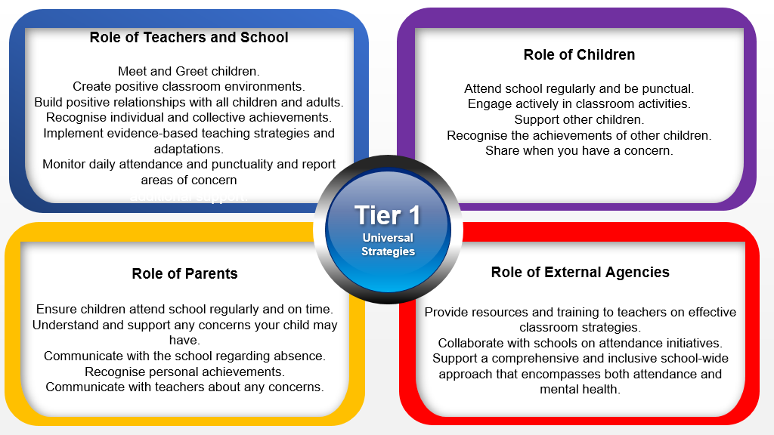

 Tier 2 – Internal individualised Strategies and Early Help Support: Tailoring strategies to individual needs and providing early help support for persistent attendance challenges.

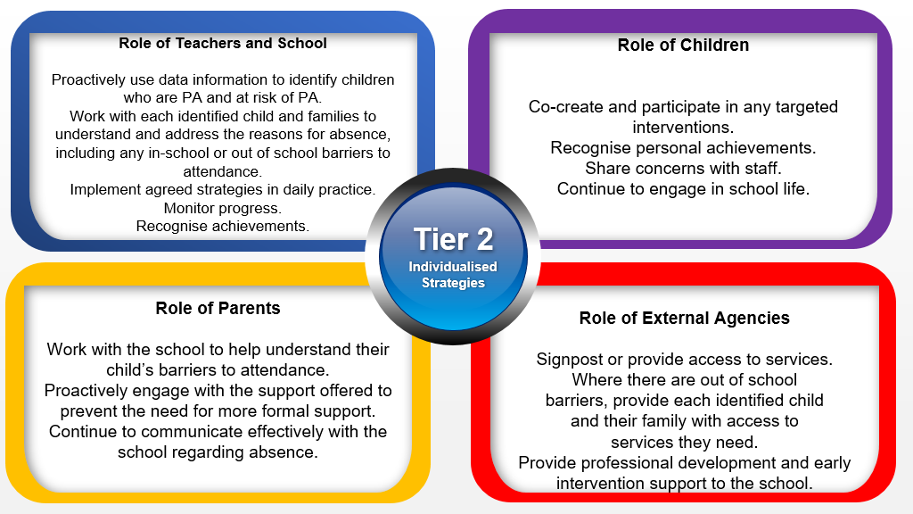

Tier 3 - Higher Needs Strategies Support: Furnishing specialised support for children, young people, and families with complex attendance requirements, including access to external agency support when necessary.

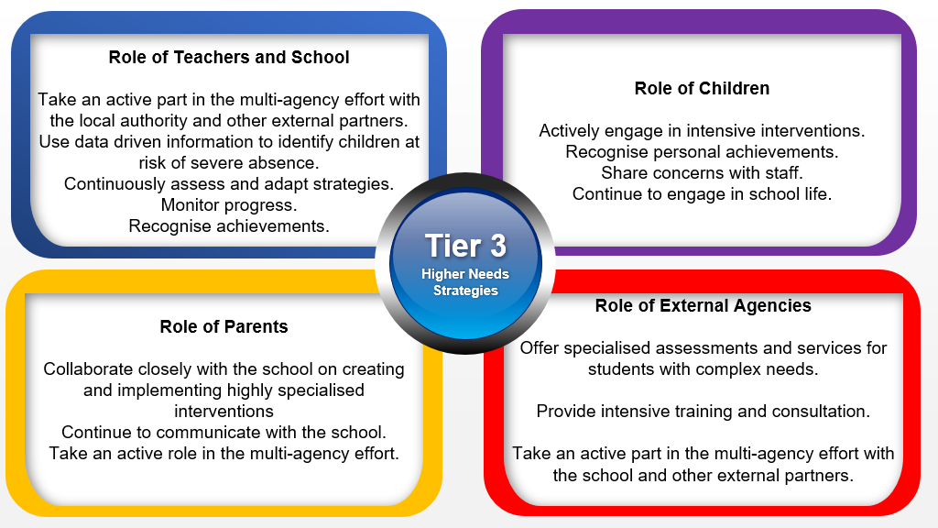

# Appendix 3 - Strategies for Promoting attendance:

Promoting good attendance is essential for child success and overall school improvement. Here are several strategies that schools can implement to encourage regular attendance:

1. Create a Positive School Climate

* Welcoming Environment: Ensure the school is a safe, welcoming, and inclusive place where children feel valued and supported.
* Positive Relationships: Foster strong relationships between children and staff to create a sense of belonging and engagement.

2. Clear Communication of Expectations

* Attendance Policies: Clearly communicate the school's attendance policies and expectations to children, parents, and staff.
* Importance of Attendance: Regularly emphasize the importance of good attendance for academic success and personal growth through assemblies, newsletters, and parent meetings.

3. Recognition and Incentives

* Awards and Certificates: Recognize children with perfect or improved attendance with certificates, awards, and public recognition.
* Incentive Programs: Implement incentive programs such as special events, privileges, or rewards for good attendance.

4. Parent and Community Engagement

* Parent Education: Educate parents about the importance of regular attendance and how they can support their children.
* Regular Communication: Maintain open and regular communication with parents about their child's attendance, including notifications of absences and updates on attendance records.
* Community Partnerships: Collaborate with community organizations to provide resources and support to families, such as transportation assistance or health services.

5. Early Identification and Intervention

* Monitoring Systems: Implement systems to monitor attendance daily and identify children who are at risk of chronic absenteeism.
* Early Intervention: Address attendance issues early by contacting parents and providing support to children who show signs of attendance problems.

6. Child Support Services

* Counselling and Mentorship: Provide counselling and mentorship programs to support children facing personal, social, or academic challenges affecting their attendance.
* Health Services: Offer access to school health services to address health-related barriers to attendance.

7. Engaging Curriculum and Instruction

* Relevant Curriculum: Develop a curriculum that is engaging and relevant to children' interests and future goals to increase their motivation to attend school.
* Active Learning: Use active and interactive teaching methods to make learning more engaging and enjoyable.

8. Addressing Barriers to Attendance

* Transportation Solutions: Provide transportation solutions for children facing challenges getting to school, such as bus services or carpool arrangements.
* Flexible Scheduling: Offer flexible scheduling or alternative education programs for children who struggle with traditional school hours or settings.

9. Professional Development for Staff

* Training on Attendance Strategies: Provide training for staff on effective strategies to promote good attendance and address absenteeism.
* Building Relationships: Train staff on how to build positive relationships with children and engage them in learning.

10. Use of Technology

* Attendance Tracking Apps: Utilize attendance tracking apps and systems that allow for real-time monitoring and easy communication with parents.
* Digital Reminders: Send digital reminders to parents and children about the importance of attendance and upcoming school events.

11. Celebrating Attendance Milestones

* Monthly Recognition: Celebrate monthly attendance milestones with school-wide announcements, bulletin boards, or assemblies.
* Peer Recognition: Encourage peer recognition by allowing children to nominate classmates who have shown significant improvement in attendance.

12. Support for Special Populations

* Individualized Plans: Develop individualized attendance plans for children with special needs, chronic health issues, or other challenges.
* Cultural Sensitivity: Be culturally sensitive and aware of the specific needs and challenges faced by children from diverse backgrounds.

Example of a Comprehensive Attendance Improvement Program:

1. Kick-Off Assembly: Start the school year with an assembly to emphasize the importance of attendance, introduce the recognition program, and motivate children.
2. Monthly Attendance Challenge: Introduce a monthly attendance challenge where the class with the highest attendance rate receives a special reward.
3. Attendance Tracking System: Implement an electronic attendance tracking system that sends automated notifications to parents for each absence or tardy.
4. Parent Workshops: Organise workshops for parents to discuss strategies for supporting their children's attendance and address any concerns.
5. Mentorship Program: Pair children with attendance issues with staff or peer mentors who can provide guidance and support.
6. Community Resource Fair: Host a resource fair with community partners to provide families with information and resources on transportation, health care, and other support services.